Задание 1

import turtle  
t = turtle  
while True:  
 t.speed(000)  
 t.forward(150)  
 t.left(90)

2

import turtle  
t = turtle.Turtle()  
t.speed(10)  
t.goto(0,0)  
t.goto(50 , 0)  
t.goto(50 , 90)  
t.goto(0,0)  
turtle.done()

3

import turtle  
t = turtle.Turtle()  
t.speed(10)  
turtle.bgcolor('orange')  
t.circle(80)  
turtle.done()

4

from turtle import *  
a = 170  
b = 90  
for i in ('yellow','black'):  
 color(i)  
 circle(a, 45)  
 circle(b, 90)  
 circle(a, 90)  
 circle(b, 90)  
 circle(a, 45)  
turtle.done()

5

import turtle  
t = turtle.Turtle()  
t.speed(10)  
t.begin_fill()  
t.fillcolor("red")  
t.penup()  
t.goto( 30 , 0)  
t.pendown()  
for i in range(5):  
 t.forward(200)  
 t.right(144)  
t.end_fill()  
turtle.done()

6

import turtle  
colors = ['red' , 'green' , 'blue' , 'orange' , 'purple' , 'yellow']  
t = turtle.Turtle()  
t.speed(0)  
for i in range(15):  
 color = colors[i % len(colors)]  
 t.pencolor(color)  
 t.circle(50)  
 t.penup()  
 t.right(30)  
 t.pendown()  
  
turtle.done()

7

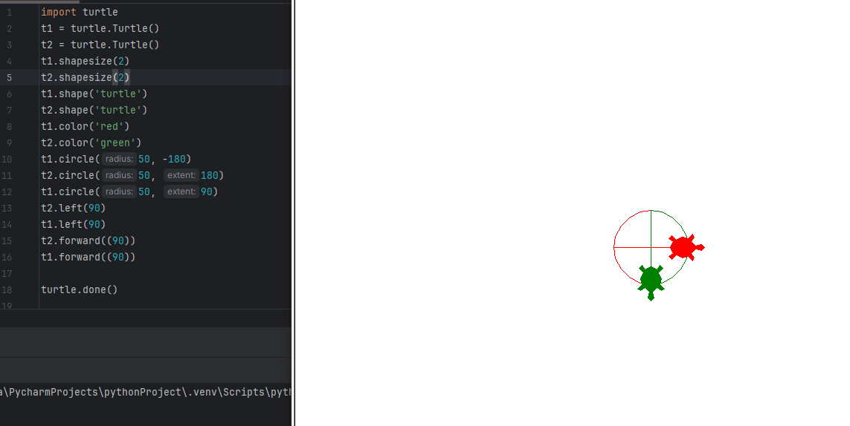

8

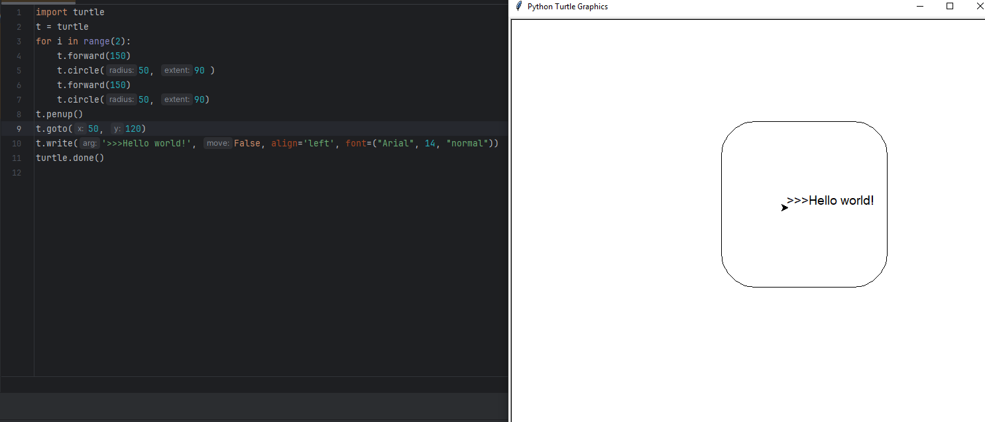

9

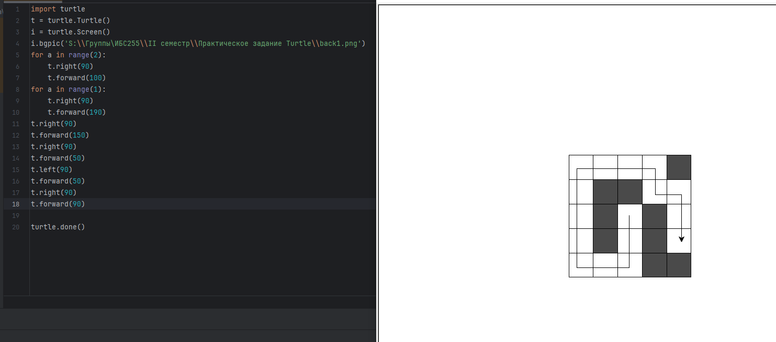

10

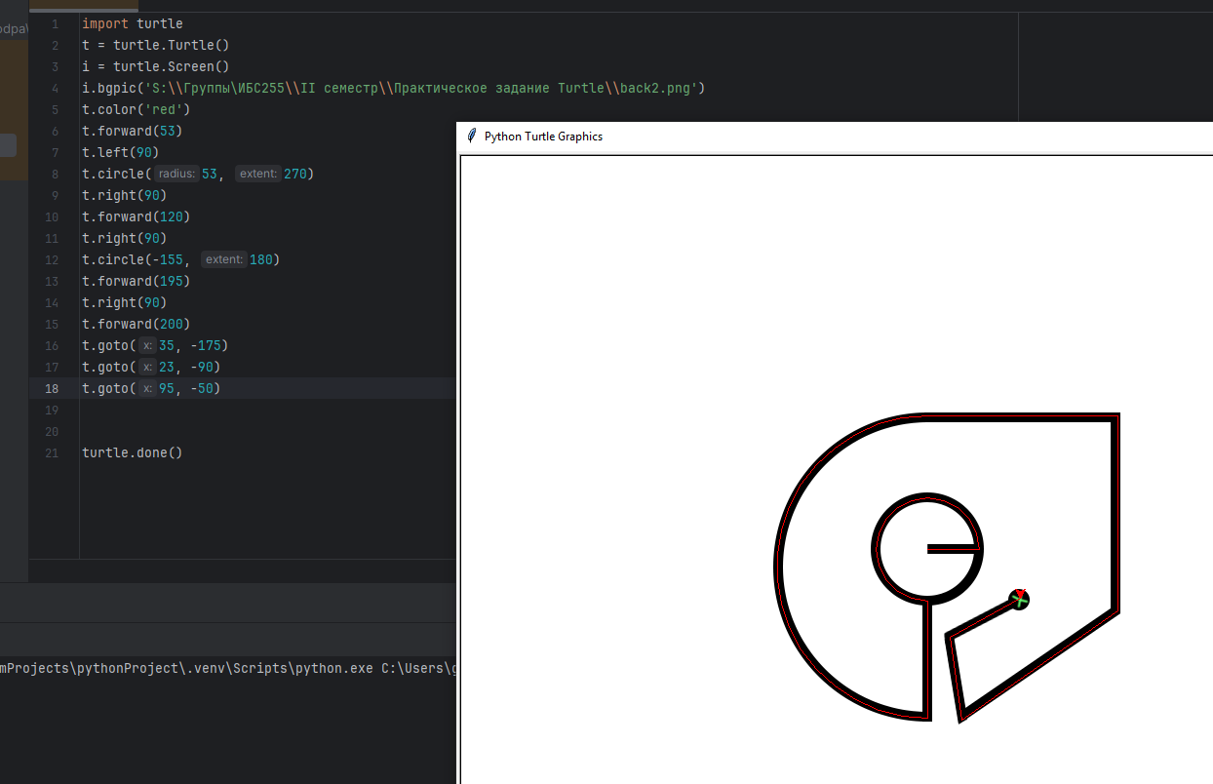

11

1. import turtle  
   t = turtle  
   for a in range (0, 4):  
    i = ['blue', 'green', 'red', 'orange']  
    color = i [a % len(i)]  
    t.color(color)  
    t.begin_fill()  
    t.circle(80, 360)  
    t.end_fill()  
   t.done()

12

import turtle  
t = turtle.Turtle()  
back = turtle.Screen()  
txt = back.textinput('Выберите направление:', 'w, a, s, d')  
t.left(90)  
count = 0  
while txt != 'exit':  
 txt = back.textinput('Выберите направление:', 'w, a, s, d')  
 txt1 = back.numinput('Количество шагов:', 'Введите величину:')  
 if txt == 'w':  
 t.forward(txt1)  
 if txt == 'a':  
 t.left(90)  
 t.forward(txt1)  
 if txt == 's':  
 t.left(180)  
 t.forward(txt1)  
 if txt == 'd':  
 t.right(90)  
 t.forward(txt1)  
 count += txt1  
 if txt == 'exit':  
 break  
 print(count)  
turtle.done()

13